

**Kyle Bern**

Student number: s**3889316**

Email: [s3889316@student.rmit.edu.au](mailto:s3889316@student.rmit.edu.au)

[GitHub Repository](https://github.com/s3889136/COSC2196-Introduction-to-Information-Technology-Assessment-1-My-Profile)

GitHub Pages

*ABOUT ME*

My name is Kyle Bern, and I am from a small town in Queensland with a little ambition. My family and I are German and Aboriginal, and I have been here my entire life. I did not graduate from high school, but shortly after I completed my Certificate IV in Adult Tertiary Preparation.

My personal hobbies include music, reading, sports and the occasional visit to the gym. My partner and I are blessed with three pet cats named Nyla, Tibbin and Suki.

The most interesting fact about me would have to be when I was a child, and I grew fond of the piano for many years. IT has been my priority since then, but I am very much still interested.

**

*MY INTEREST IN IT*

I am interested in Cyber security and this has been a long-time interest of mine. My entire time being apart of IT, Cyber security has always been the most interesting. Defending systems and data from malicious attacks has always appealed to me as a hopeful career path one day.

My family has always needed some help in hand on the IT side of things with various devices over the years. This all fell on me to fix and help setup and after applying the finishing touch to a setup or a repair was just somewhat special to me.

My first experience was when my parents bought me a laptop for Christmas. It was a enormous gift in my eyes and the start, the very first bit of IT equipment I ever got. This Toshiba laptop I did everything with, from schoolwork to everyday browsing, and even some games. There was a website I liked very much but cannot quite remember the name of it. I would right-click and inspect the element of the page and change the values on the website. For example, I would change the title page of the website to my name and various other things.

I have worked in a technician and help desk role at a non-for-profit health organization. I have experienced and understood what is needed to function independently, alone and collaborating within a team.



*RMIT*

Information technology has always been my thing, the one thing I have always wanted to pursue and have a career in one day. After looking at various universities, RMIT was so much more accessible to me and given its reputation I thought it was a perfect opportunity for me to better myself and get a degree not only at a university but RMIT.

In my studies at RMIT, I expect to be ready with the tools and resources that I need to start my career in information technology and I intent to further my study and education towards speciality in cyber security down the track.

*IDEAL JOB*

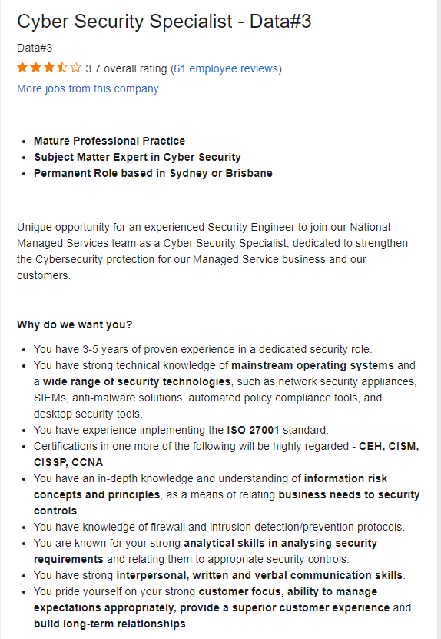Cyber Security Specialist

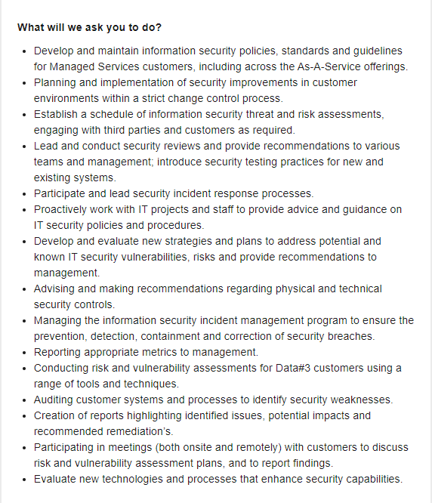

 *DESCRIPTION*

Data#3 is a cloud solutions and ICT service provider in Sydney looking for an experienced cyber security analyst with 3-5 years of proven experience. This IT role requires a lot of knowledge and experience. Developing new security policies and strategies and addressing known IT security vulnerabilities, risks and recommendations to management.

This position is impressive to me and appeals to me in all sorts of ways. This role involves large amount of information security practice and responsibility to you and your colleagues/team.

*SKILLS*

* 3-5 years of proven experience.
* Strong technical knowledge as well as security technologies.
* Bachelor’s degree or Masters.
* Strong understanding of information risk concepts and principles.
* Certifications of CEH, CISM, CISSP and CCNA are highly regarded.

*SKILLS I HAVE*

* No proven experience in cyber security field.
* Basic knowledge on cyber security systems and technologies.
* Job experience in an IT role that can be useful if in a customer or colleague facing roll/situation.
* No certifications.

**

*PLAN*

* Finishing IT undergraduate qualification at RMIT to achieve and obtain a graduate role in said field (Cyber Security)
* Grasp and endure proven experience in cyber security
* Learning about the systems and technologies and working towards beginner external certifications used in the workplace.
* Further certifications from beginner to intermediate and so on.

This plan is not a step by step more of a reminder and set of multiple tasks done in the same time frame.

*PERSONAL PROFILE*

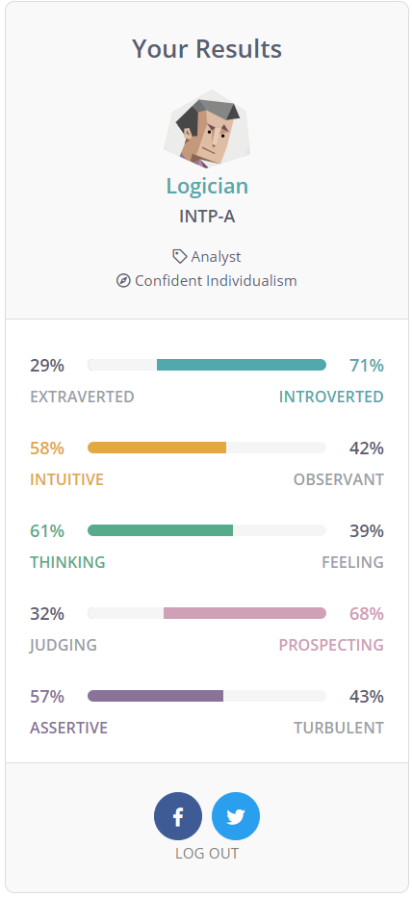

These results for my personality test are somewhat accurate. In most situations be it informational I tend to be quiet and listen. I observe and analyse situations, people, outcomes and just majority of things. I like to find out how things work and if something does not work then finding a solution is right up my alley.

Forming a team with this personality type is interesting for me as I like to work alone most of the time. Collaborating with people and functioning as a team are very big elements in the workplace and learning environments.

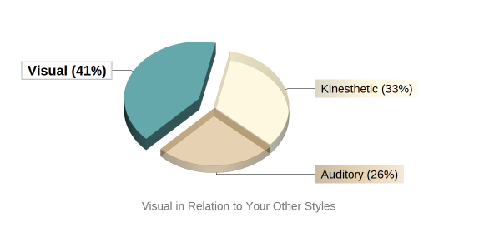personalitymax.com

I am a visual learner. I prefer visuals, seeing things when I learn. Seeing examples and how it’s done as this helps me learn and understand problems and solutions a lot easier.

OPENPSYCHOMETRICS.ORG

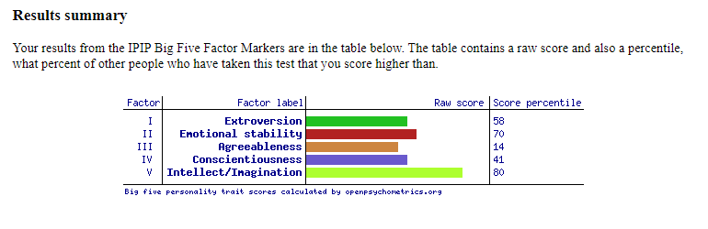

Strengths –

* Positive emotionality
* Openness to experience
* Introvert and extrovert Behaviours

Weaknesses –

* Introvert and extrovert Behaviours
* Critical
* Unorganized

I am friendly with a open mind. Keen to learn new things but I prefer working alone and depending on myself with things as I am critical in teamwork-oriented scenarios. I tend to be unorganized with studies and will have a lot of different timed bursts of productivity, no real schedule. This does not work well with team compositions.

*PROJECT IDEA*

**Overview** /

This project is a 2D jump/dash puzzle game, a multiple level game developed by Unity Engine.

This game will consist of a block going through a map made of jumping puzzles, while your character stays in the exact same position only able to jump. The background will continue to move as you progress through the level. This game will feature soundtracks on various levels made appropriate to the difficulty of the level/s.

**Motivation** /

The gaming audience is bigger than ever, and its industry says the same. Being creative in this field can be so rewarding when someone enjoys one of your creations even if its just a 2D game designed in 2021. Some of my favourite games are 2D.

**Project Description** /

The game is a 2D jump/dash puzzle game with multiple levels and as you progress through level you experience an appropriate soundtrack throughout the level. Harder the levels the more intense the music.

This game will be a one button game and the only function you can control is jumping. You will be travelling through a level with music and jumping puzzles, various platforms to jump to and obstacles to jump over.

Each level will visually feel the same, but the actual difficulty greatly increases with every level, allowing a large room for improvement needed between each level.

Each level will be recognizable by audio, every level will have a distinctive soundtrack that you will remember. The feeling of difficulty with every different soundtrack.

Throughout the level there will be 3 stars to obtain to grant you the achievement for each level, but you must obtain all within the run of the level.

Your shape will shatter when you miss a platform or hit an obstacle.

Players will have to restart the entire level when they fail to progress through a part of the level, making the game more difficult, and that much more rewarding when you finish a level from start to finish.

When you complete a level, your progress will be recorded and when every level is completed you will unlock bonus features for the game.

If all stars are obtained throughout your playthrough, you will be rewarded.

**Animation /**

* Main character: Jumping animation and Death animation
* Background: colour patterns slowly moving
* Stars: Rotating animation within the level

**Sound** /

* Level soundtrack
* Falling off a platform
* Hitting an obstacle
* Collecting stars
* Completing the level

**Technology** /

Hardware –

* Processor: 3.7 GHz Quad-Core Intel i7
* Memory: 16 GB DDR4

Software –

* Windows 10
* Unity game engine
* Visual Studio

**Skills** /

* Ability to use unity game engine and visual studio
* C# programming
* Animation and physics
* Design of assets or importing

**Outcome** /

The outcome is a 2D one button mobile game with multiple levels. The difficulty increases with each level. The game consists of soundtrack driven maps with jumping over obstacles and to platforms. Hitting an obstacle or missing a platform will result in a death animation sending you straight back to the start of the level or you to attempt again. Each level will have difficult obtainable stars to collect for an extra reward at the end. There will be a death sound and the level’s soundtrack and menu sounds. The background will slowly move while progressing through the level. the harder the levels the more intense the music gets.